

Tsort
Architecture

Revision History
Date | Version | Description | Author
02/13/07 | 1.0 | Created | Jim Heary
02/27/08 | 2.0 | Revised | Jim Heary

Table of Contents
Overview 3
Business Context 3
Key Abstractions 4
TL States 5
Application Design 6
Overview 6
Design Model 6
Security 6
Deployment 7
Overview 7
Deployment Model 7
Configuration 7

Overview
Zone Closing is an Argix business process that manages routing of sorted cartons, organizes groups of outbound freight (TL’s), and associates outbound freight with line-haul schedules. This process includes the following activities:
- view active zones with open TL’s and lane assignments at a terminal
- set lane\small lane assignments for a zone (carton routing)
- close an ‘open’ zone (close the current TL) and generate a new TL for that zone
- attach TL’s to trips (loads) on a ship schedule for outbound, line-haul delivery

Business Context
Zone Closing is managed by the Shipping Clerk in the Shipping Office. Each zone has an open TL, which serves as an identifier for a group of outbound freight designated to ship to a single geographical location. When a trailer has become full, or when it is desirable to identify a group of outbound freight, the TL is “closed” and can no longer accept additional freight. The TL serves as an identifier for the cartons sorted to it.

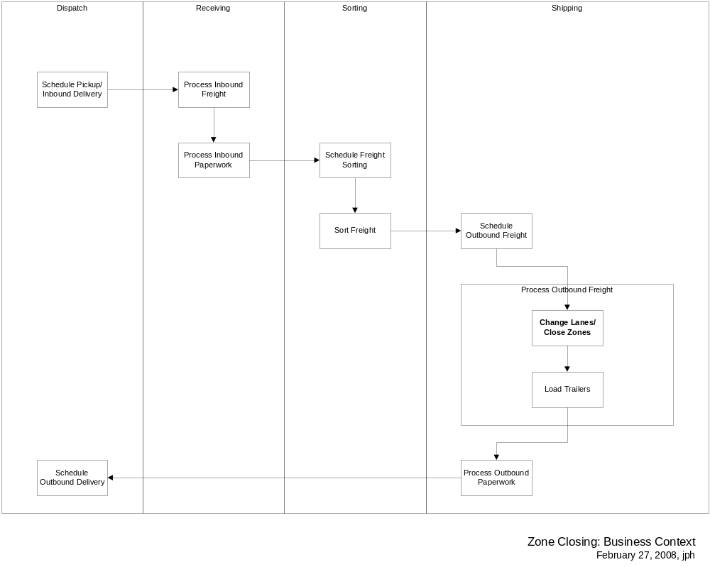

Key Abstractions
Agent- a local delivery carrier that provides delivery services in local areas for Argix; a designated contractor servicing a geographic area who receives outbound loads
Carrier- a contractor that transports freight
Company- a corporate entity
Enterprise Terminal- an Argix terminal
Lane\S Lane- refers to a numbered path within the conveyer system that terminates at a shipping door
Location- a geographical address
Ship Schedule - a schedule created daily by Agent Systems that provides scheduled National trailer loads shipping for a given departure date; it lists the scheduled carrier, zone, closing time, departure and arrival times, the carrier load number and any special comments or instructions
Ship Schedule Trip- the route a driver is assigned, consisting of one or more stops
Ship Schedule Stop- a point in a delivery run where a driver stops to drop off freight
Terminal- an agent location that handles local deliveries
TL- an alpha-numeric identifier used to associate and group freight bound for a particular zone
Trailer- detachable mobile container for freight storage and transport
Zone- an identifier for a geographical delivery point

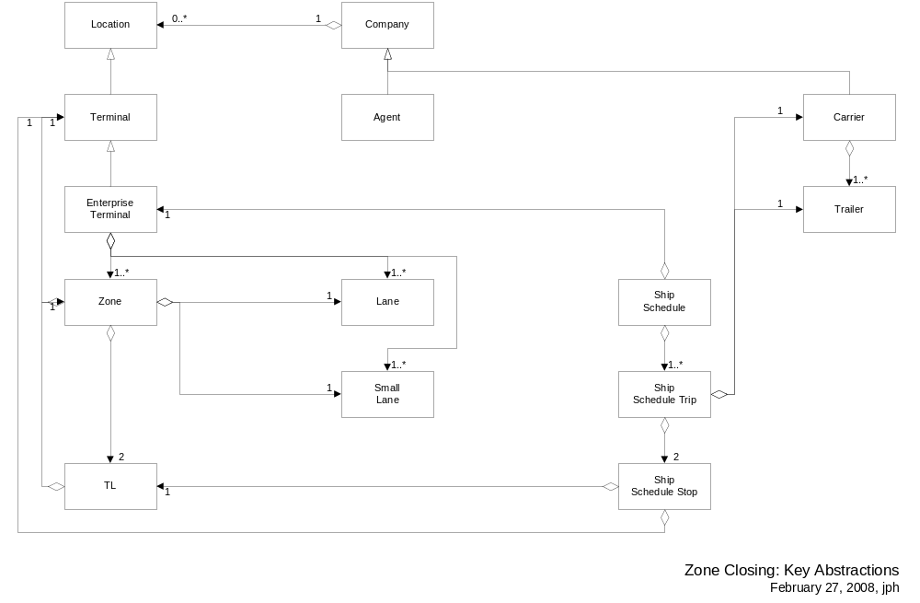

TL States
A TL begins life when it is opened (when the prior TL is closed). Valid states for TL objects within the Zone Closing are shown in the drawing below. These include:
- New- the initial state for a new TL (neither opened nor closed)
- Always- a TL that must be assigned to an open ship schedule trip prior to closing
- Optional- a TL that can be closed regardless of assignment to a ship schedule trip
- Never- a TL that never gets assigned to a ship schedule trip
- Assigned- a TL that is assigned to a ship schedule trip and can now be closed
- Closed- a TL that has been closed; closed TL’s can be moved from an open trip to another open trip

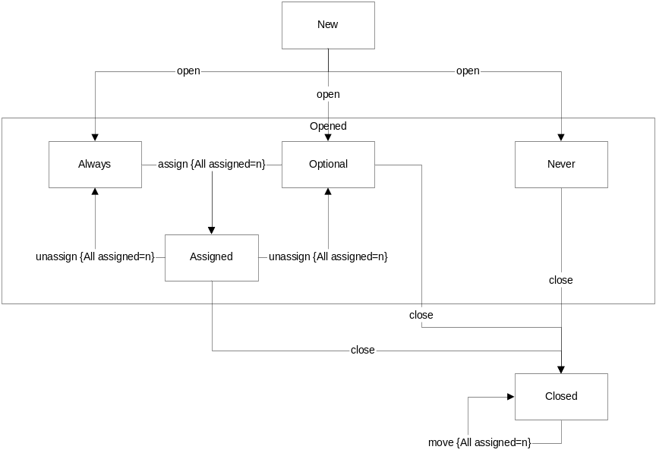

Application Design

Overview

Design Model

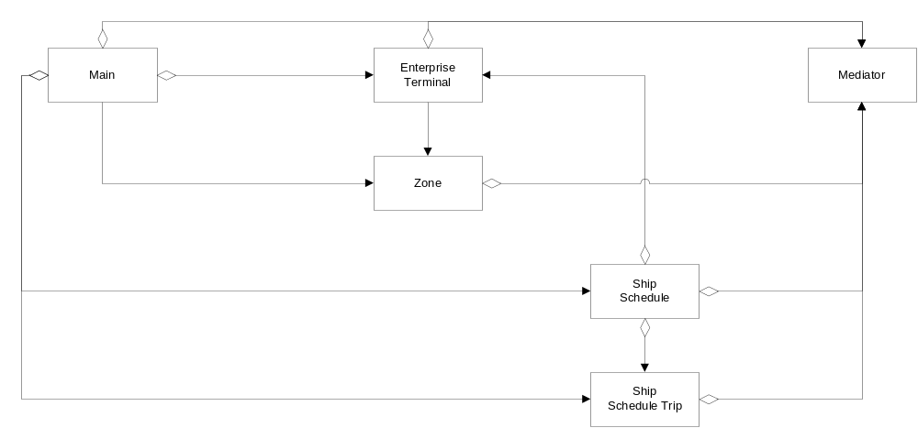

Security

Deployment

Overview

Deployment Model

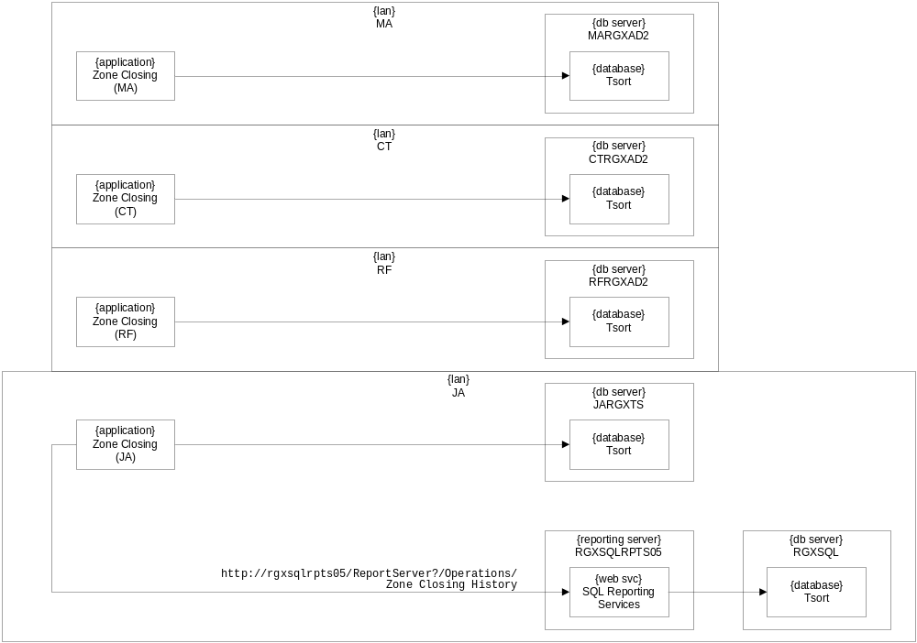

Configuration

